Fluid Flow Test



**UC Irvine Rocket Project**

**April 17, 2019**

**Advisors**

Professor Mark Walter & Professor Ken Mease

**Leads**

Brian Fox, Mitchell Martinez

Tan Nguyen, Sergio Sandoval, Richard Umboh, Sebastian Rosiak, Adam Park, Srinath Gopalakrishnan, Akash Idnani, George Ahl, Nathan Jump

**Members**

Mariam McCloskey, Amy Duong, Edward Lee, Jonathan Palafoutas, Matthew Polcyn, Jorge Karam, Wes Hellwig, Myriam Khalil, Amy Yee, Caitlyn Copeland, Derek Nguyen, Paul Badalian, Ioannis G. Mourginakis, Tyler Cook, Kaylx Jang, James Jamgotchian, Logan Marceau, Brandon Sedano, Ananth Krishnan, Simon Atkins, Daniel Tikhomirov, Donald Ordorica, Cameron Goedinghaus, Owen Browne, Kaylee Miranda, Harry Pak, Noah Yim, Ching-Hao Yu, Dohyun Park, Leo Mor

|  |  |  |  |
| --- | --- | --- | --- |
| **Release and Revision** | | | |
| **Rev** | **Description** | **Date** | **Approved By** |
| [-] |  |  |  |
|  |  |  |  |
|  |  |  |  |
|  |  |  |  |
|  |  |  |  |

**Table of Contents**

**1. Introduction** **3**

1.1 Overview 3

1.2 Background 3

1.3 Requirements 3

**2. Apparatus Assembly** **4**

2.1 Bill of Materials and Assembly Drawings 4

2.1.1 Full Test Apparatus Assembly (excluding test stand) and BOM 4

2.1.2 Avionics Shelf Assembly 6

**3. Test Specific Procedures** **7**

3.1 Plumbing Assembly 7

3.2 Test Specific Plumbing Diagram 7

3.3 Safety 7

3.3.1. General Use Requirements 7

3.4 Test Procedures 8

3.5 Contingency Test Procedures 9

**4. A.1 Additional Information** **10**

4.1. A.1.1 Required PPE 10

4.2. A.1.2 Fire Safety 10

4.3. A.1.3 Work Related-Injury, Illness, or Hazardous Material Exposure 10

4.4. A.1.4 List of Urgent Care Center/Hospital Emergency Room 11

# 1. Introduction

## 1.1 Overview

## 1.2 Background

## 1.3 Requirements

* Read and record pressure values at pressure transducers
* Manually actuate all valves through LabVIEW.
* Manually control Pressure Regulator through Labview and increment pressure from 200 to 450 PSI.
* Tank Load Cells must read and record tank weight through LabVIEW.

# 2. Apparatus Assembly

## 2.1 Bill of Materials and Assembly Drawings

### 2.1.1 Full Test Apparatus Assembly (excluding test stand) and BOM

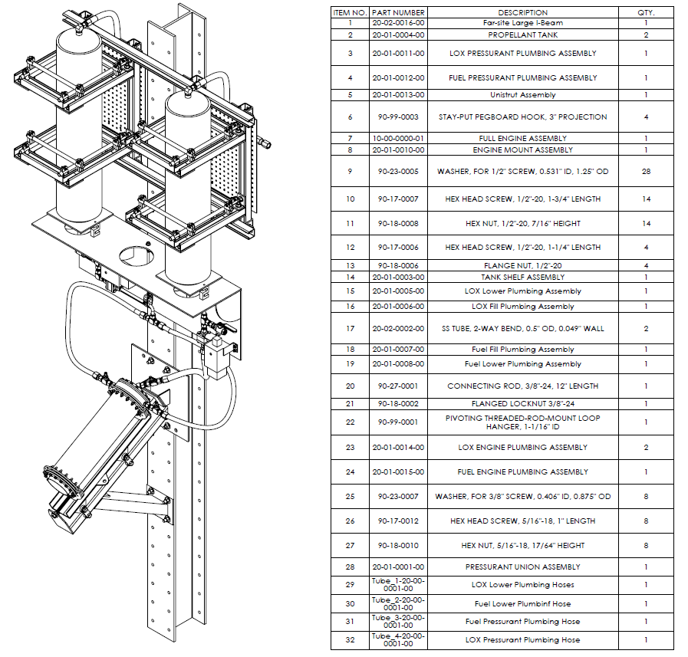

*Figure 2.1.1.1 Full Test Stand Assembly Drawing and BOM*

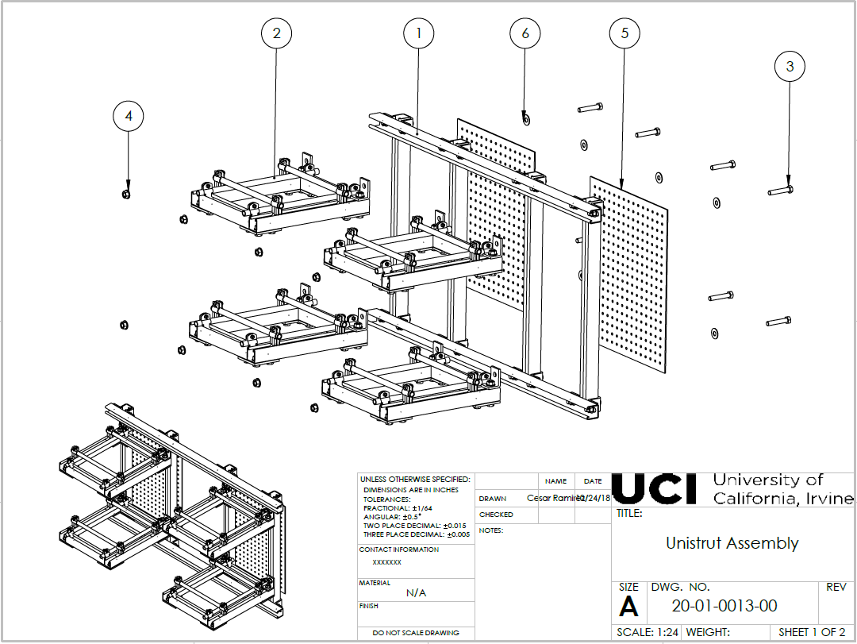

*Figure 2.1.2.1 Unistrut Assembly Drawing*

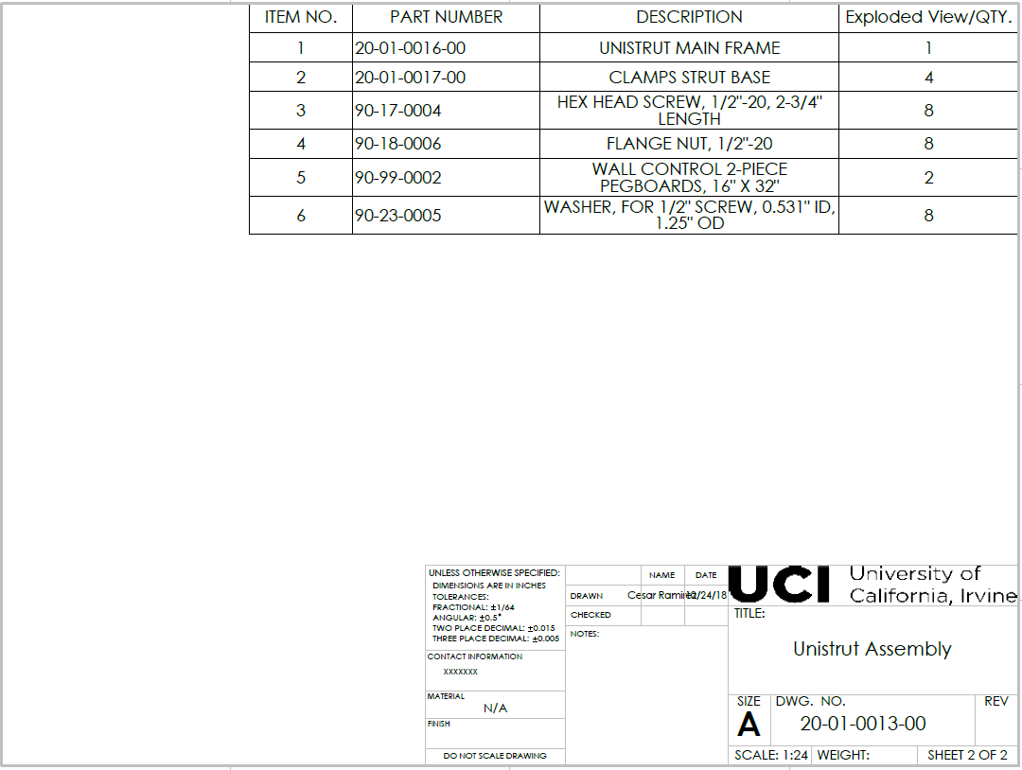

*Figure 2.1.2.2 Unistrut Assembly BOM*

# 

# 3. Test Specific Procedures

## 3.1 Plumbing Assembly

This test follows the plumbing procedures listed in section 2.4 of the Preliminary Test Rocket (PTR) Master Test Procedures.

## 3.2 Test Specific Plumbing Diagram

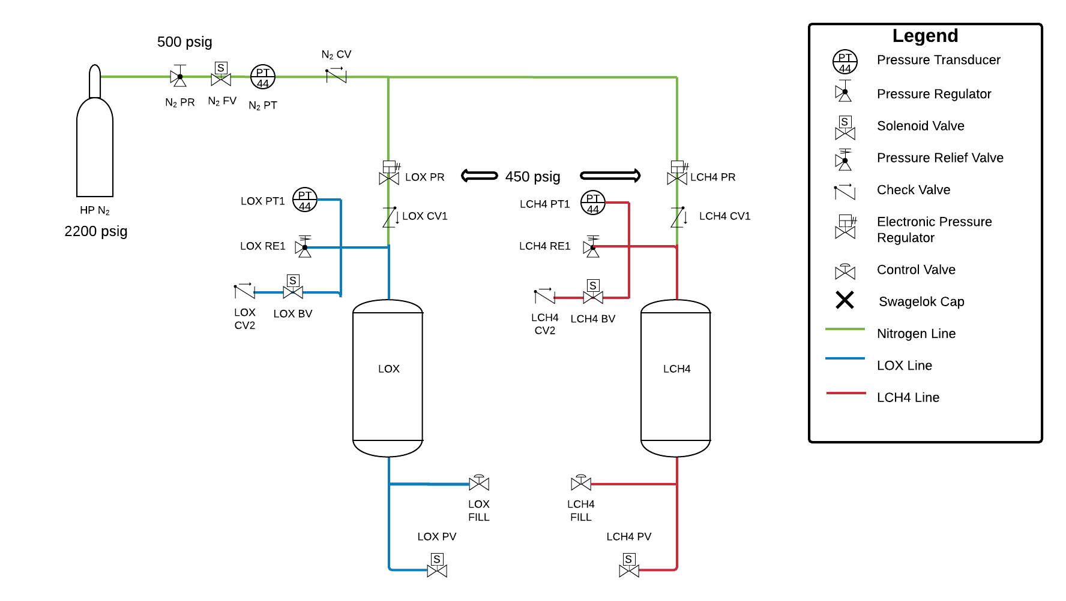

## 3.3 Safety

### 3.3.1. General Use Requirements

* Keep valve protection caps in place until ready to use.
* Close the compressed gas cylinder valve when equipment is not in use.
* Use the cylinder valve, not the regulator, for turning off the gas.
* Close the cylinder valve and release all pressure before removing the regulator.
* Never heat cylinder – even when partially empty – with any device that could raise the surface temperature of the cylinder to above 125º F.
* Keep the cylinder clear of all electrical circuits, flame, and sparks.
* Do not approach system when it is pressurized to greater than 75 psi. Over 150 psi is considered a high hazard system.

**Safety:** **Safety glasses, close-toed shoes and long pants are to be worn at all times. Use a respirator and nitrile gloves if necessary.**

## 3.4 Test Procedures

<https://docs.google.com/document/d/1EVfVbbK5K-R2Av30GuJ3C5q8RpItM7JyivIIxjcH-pQ/edit>

## 3.5 Contingency Test Procedures

There are several contingency situations that must be considered in this test. These include but are not necessarily limited to denting or destroying an Airgas tank, damaging LCH4 or LOX tanks, and damaging any line components such as fittings or the line itself. Contingency procedures for these situations are listed below.

Airgas tank is dropped without obvious leakage or explosion:

1. Carefully lift tank and load onto hand truck.
2. Strap carefully to hand truck and move to a safe location.
3. Once moved make sure the tank is secured in the standing position.
4. After the test is complete contact Airgas to have the tank replaced as soon as possible.

Airgas tank is dropped and clearly destroyed or has a large leak:

1. If the tank is clearly leaking do not move the tank.
2. Call the fire department as a damaged tank must be handled by a professional.
3. If the tank is completely destroyed and the there is clearly no pressure remaining the tank can be removed from the work area.
4. After the test is completed contact Airgas to have the tank replaced as soon as possible.

Either LCH4 or LOX tanks are in anyway damaged:

1. Recalculate theoretical pressure limit and factor of safety on the tanks to see if anything may have been missed.
2. Design of new tanks must be implemented as soon as possible after the procedure is completed.

Fittings are damaged:

1. Check to make the fittings were able to withstand the pressure they were introduced to.
2. If fittings were within operating range contact manufacturer to make sure of this.
3. If manufacturer confirms fittings were within operating range see if we can get refund and new fittings delivered due to failure.

Loss of power/DAQ loses connection:

1. All valves except bleed valves close.
2. Water in the tanks leave the system through the bleed valves.

Ball valves burst (LOX and LCH4 PV Valves (???))

1. Will occur if manual regulator breaks, exposes the line to >2000 psi
2. Water in the tanks are released at high pressure

# 4. A.1 Additional Information

## 4.1. A.1.1 Required PPE

1. Safety glasses/goggles
2. Puncture resistant gloves
3. Close-toed shoes
4. Long pants

## 4.2. A.1.2 Fire Safety

According to OSHA, there are different types of fire extinguishers designed to put out different types of fires. A fire live electrical systems are classified as a Class C fire. Dry chemical fire extinguishers are designed to be able to put out class C fires; as such, a standard fire extinguisher that is found in the Rocket lab will be sufficient to put out any fires that may occur during the test.

When using the extinguisher, operators will use the PASS system:

P—Pull the pin on the extinguisher

A—Aim at the base of the fire

S—Squeeze the handle

S—-Sweep at the fire, moving from side to side

In case of fire, use the nearest exit and meet at a “designated assembly point” (EH&S Fire Safety Guidelines).

## 4.3. A.1.3 Work Related-Injury, Illness, or Hazardous Material Exposure

**1) Call 911 if the condition is LIFE THREATENING or REQUIRES IMMEDIATE**

**MEDICAL ATTENTION.**

2) Notify your supervisor or faculty staff if condition is not life threatening. Seek medical as

follows:

3) Undergraduate Students (non-UCI employees):

Campus: Student Health Center (East Peltason & Pereira) Call 949-824-5304.

Hours: M-F 7:30am-5:30pm

After hours: Go to the nearest urgent care center or hospital emergency room (listed

below).

Be sure to contact Student Health Center for follow-up care as soon as

possible.

The Student Health Center is the primary care facility for students covered by the Undergraduate Student Health Insurance Plan (USHIP). Undergraduate students with private health insurance instead of USHIP will be charged for services rendered at the Student Health Center and provided a receipt to obtain reimbursement.

4) Employees or their supervisor must contact UCI Worker’s Compensation Desk at

949-824-9152 during regular working hours to obtain medical authorization within 24 hours of any injury.

ALL WORK RELATED INJURIES MUST BE REPORTED via the [On-line Incident Form](https://www.ehs.uci.edu/apps/hr/index.jsp) or call (949) 824-9152 .

For the UCI Rocket Lab, you must also submit a separate [incident report](https://docs.google.com/document/d/1jAyqLA50mtSrOsfg0GsyeRe80Nxw4zXldS5qOWdzXCY/edit#bookmark=id.gjdgxs) for the Base 11 Space Challenge

([Guide to Workers’ Compensation](http://apps.adcom.uci.edu/cms/public/HumanResources/WorkersCompensation/GuideToWorkersComp.pdf) depending on the level of injury)

## 4.4. A.1.4 List of Urgent Care Center/Hospital Emergency Room

Newport Urgent Care (949) 752-6300

Located off campus ([map](http://apps.adcom.uci.edu/cms/ResourceAC/public/HumanResources/WorkersCompensation/NewportUrgentCareMap.pdf)) - 1000 Bristol Street North, Suite 1-B, Newport Beach (Bristol & Jamboree)

Mon-Fri 8:00 am-9:00 pm; Sat & Sun 9:00 am-6:00 pm; Call for after-hours physician.

Occupational Health Clinic at UCI Medical Center (714) 456-8300

Located on campus ([map](http://apps.adcom.uci.edu/cms/public/HumanResources/WorkersCompensation/UCIMedicalCenterMap.pdf))- Pavilion III, Building 29

Mon-Fri 7:30 am- 5:00 pm, Closed Sat & Sun; After hours - Go to UCIMC emergency room

Memorial Occupational Medical Services (562) 933-0085

1720 Termino Avenue, Long Beach, CA 90804 ([map](http://apps.adcom.uci.edu/cms/public/HumanResources/WorkersCompensation/LB_Memorial_Occupational_Map.pdf))

Mon-Fri 7:00 am- 9:00 pm; Call for after-hours physician services.

ProCare Work Injury Center (949) 752-1111 17232

Red Hill Ave. Irvine, CA 92614 ([map](http://apps.adcom.uci.edu/cms/public/HumanResources/WorkersCompensation/ProCareWorkInjuryMap.pdf))

Mon-Fri 7:00 am - 6:00 pm; Call for after-hours physician services

**5. Failure Mode and Effects Analysis**

**5.1 Risk Assessment Matrix**

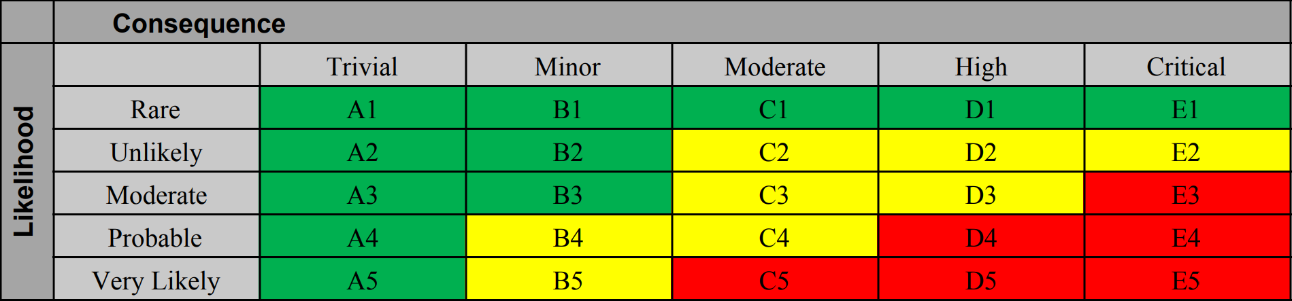

**5.2 Table:**

|  |  |  |  |  |
| --- | --- | --- | --- | --- |
| **Failure Modes** | **Causes** | **Effects** | **Severity**  **& Likelihood** | **Mitigations** |
| He Tank Leakage | Improper handling of tank | Release of helium | C3 | Follow proper steps and precautions with cylinder relocation and analyze tanks regularly for damages |
| He Tank Explosion | Severely high pressure; capacity is ... | Tank explosion | E2 | Continuously monitor pressure readings and use the manual regulator to ensure the proper pressure |
| LCH4/LOX Tank Leakage | Improper handling of tank | Release of water | C4 | Follow proper steps and precautions with cylinder relocation and analyze tanks regularly for damages |
| Fittings are damaged | Unable to withstand the pressure | Valves will not be secure during test | C2 | Contact manufacturer and confirm operational range of fittings |
| Loss of power/ communication | Electrical fault | Most valves are fail close so the system will be pressurized | D2 | Bleed valves are fail open so the system will automatically depressurize |
| Valve fails to close | Not sealed properly or damaged over time/ loss of power | Excess flow of water out of system | C3 | Monitor pressure readings consistently |
| Valve fails to open | Valve not verified properly | Water does not exit system | C3 | Monitor pressure readings consistently |
| Regulator Malfunction | Faulty sensors/lack of calibration | Incorrect reading of pressure/excessive pressure in the system | B5 | Perform proper calibration |

Federal Regulation 14 CFR part 25 specifies requirements for MPVs used in pressurization and pneumatic systems as follows:

(a) Pressurization system elements must be burst pressure tested to 2.0 times, and proof pressure tested to 1.5 times, the maximum normal operating pressure.

(b) Pneumatic system elements must be burst pressure tested to 3.0 times, and proof pressure tested to 1.5 times, the maximum normal operating pressure.

(c) An analysis, or a combination of analysis and test, may be substituted for any test required by paragraph (a) or (b) of this section if the Administrator finds it equivalent to the required test.

(d) Damage-tolerance evaluation. The evaluation must include a determination of the probable locations and modes of damage due to fatigue, corrosion, or accidental damage. The determination must be by analysis supported by test evidence and (if available) service experience. Damage at multiple sites due to prior fatigue exposure must be included where the design is such that this type of damage can be expected to occur. The evaluation must incorporate repeated load and static analyses supported by test evidence. 15

(e) The extent of damage for residual strength evaluation at any time within the operational life must be consistent with the initial ability for its detection and its subsequent growth under repeated loads. If significant changes in structural stiffness or geometry, or both, follow from a structural failure, or partial failure, the effect on damage tolerance must be further investigated.

(f) Fatigue (safe-life) evaluation. Compliance with the damage-tolerance requirements of paragraph (d) of this section is not required if the applicant establishes that their application for a particular structure is impractical. This structure must be shown by analysis, supported by test evidence, to be able to withstand the repeated loads of variable magnitude expected during its service life without detectable cracks. Appropriate safe-life scatter factors must be applied.